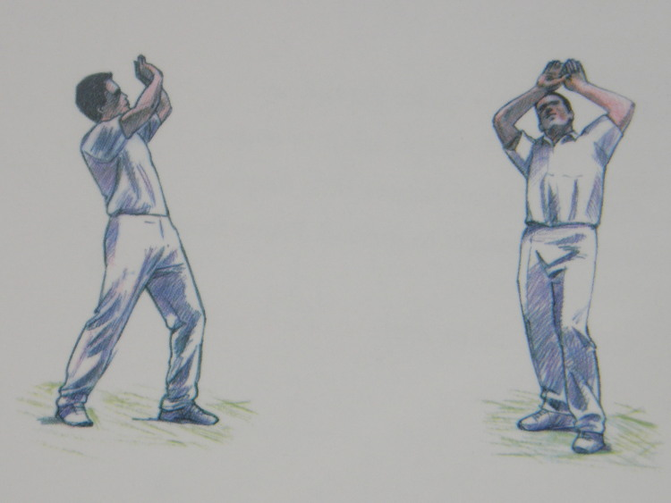
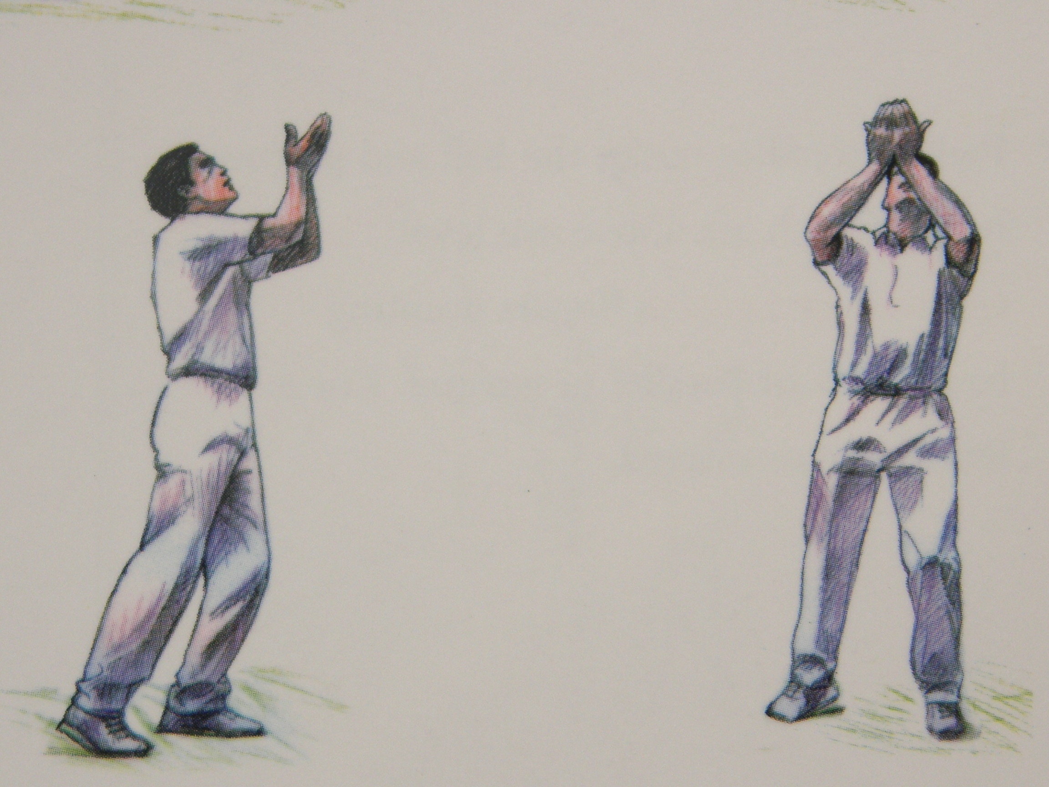
High Catching
These drills will help players develop their high catching skills, whilst improving their agility, concentration, co ordination and ability. Make sure they get to the ball/into position quickly and adopt a balance stable base to enable them to catch the ball. Dependent upon its height/trajectory they will catch it traditional style with the palms facing the body or reserve cup with the palms facing the ball. If they are catching the ball in front of their face make sure they take their head out the way at the last minute or catch the ball to either side of the head. Always make the drills safe, fun and don’t forget to introduce a competitive element.

Two players stand 15-20M apart. Player 1 throws the tennis ball high, initially underarm lob throw, to Player 2. Player 2 catches it and throws the ball back underarm to Player 1. Repeat 5 times and then reverse roles. Make the drill more demanding by increasing the distance the players stand apart, using an over arm throw to increase the height of the thrown ball for Player 2 to catch, different makes and types of ball, EG, use a slaz ball, cricket ball, golf or squash ball. If indoors mind the sports hall ceiling/roof! Players could line up behind Player 1 and take in turns, so making it a Team drill. Why not have two Teams? A warm up drill?

As above but Player 1/Coach has a Tennis racket to hit tennis balls. The players should start 15-20M apart and Player 1/Coach should not hit the tennis ball too hard. As the drill progresses and Player 1/Coach starts to hit the ball harder they will probably, if space permits, need to increase the distance between each other. Progress by using Slaz balls and then change to a cricket bat/fielding bat and cricket balls. You could again make it into a Team drill and competition. Use cones to indicate the catchers’ starting position. You would also probably introduce a keeper to catch the ball after Player 2 has caught it. The keeper would be positioned, behind a stump, to the side of Player 1/Coach and feed the ball to Player 1/Coach so he can hit it again.
1
1

Kannon
Player 1 lines up behind a cone and the Coach, using a Kannon, fires a slaz ball to a comfortable height, every 5 seconds for Player 1 to catch. Player 1 rolls the ball back towards the Coach after catching it and jogs back to the cone ready to catch the next ball.5 catches then Player 2 replaces Player 1. To progress the Coach fires the ball higher. He can then get the Kannon to oscillate slightly so the slaz ball is fired out away from the player catching, who must return to the cone between catches.
Cone
1
2

The Coach with Tennis racket hits slaz balls at Players who line up, one in the first row, two in the second, three in the third and so on. All players must be able to see the ball being hit to enable them to catch it. They then throw the ball back to the coach or another Player/Keeper who stands to the side of the Coach. The Coach can hit low, waste/head high and high catches. The Players rotate positions every ten catches or so.
C

