


The
Devon Cricket League
www.devoncricket.co.uk

President: GRAHAM SHEARS ‘The Bungalow’ ‘Rocklands’ Station Hill. CHUDLEIGH TQ13 0EE
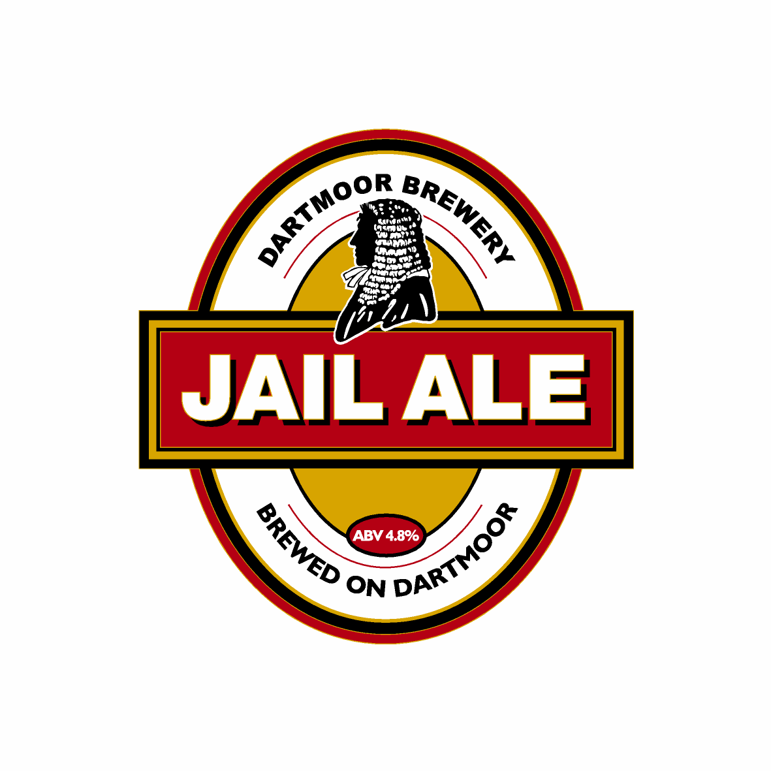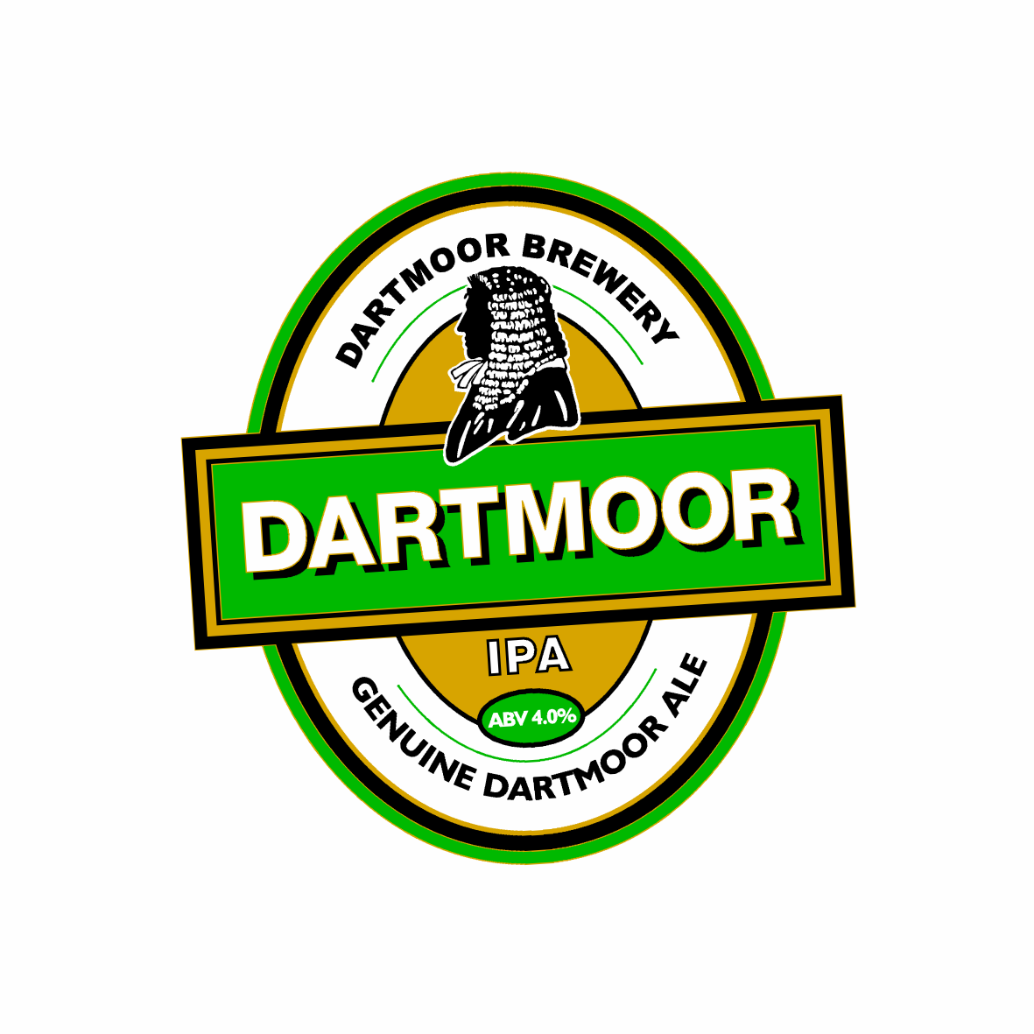
The DCL/Dartmoor Breweries Twenty/20 Competition 2009

The Devon Cricket League will again be responsible for the organisation of this event.

We are indebted to Dartmoor Breweries for their continued sponsorship in 2009.
Next season North Devon Cricket Club will be hosting the event at their Instow ground.
We have liaised with ECB regarding the rules and playing conditions and we include a draft copy of the Finals Day Programme, which includes the Rules and Playing Conditions.

The DCL will organise the event together with the sponsors and the host Club. It is hoped that all Twenty/20 countywide regional winners take part. This has been increased to seven Regions for 2009.

A draw will take place by the DCL. (E.M.C) immediately after the names of the Clubs participating are known. If necessary preliminary matches will be drawn, and the resultant winners will be invited to the finals day.

As we have said, the Rules of the Competition are enclosed and we would draw your attention to Rule 3. (Prize Money) this sets out the automatic entry into the National Competition as last year. All Clubs should aspire to this, as it was a considerable success.

The successful Club will be supplied with new kit compliments of ‘Cockspur Rum’. Last year the DCL were involved in the administration of the Regional Finals we hope that this will be repeated.

As stated earlier we are fortunate that ‘Dartmoor Breweries’ will sponsor the Competition for us in 2009. It is not intended to conflict with any sponsorship that your local competition may have but to supplement it. Last year our sponsor supported every regional final and we hope that with your organiser’s approval this will continue

Finally: To qualify for the above competition you must enter your Regional Competition.
I have set out below the Competition organisers of your local event. I have had to assume that the details are correct. If there is any amendment in the contact Name the please advise me:
Area | Contact | Contact Details
North Devon Twenty/20 Competition | Colin Payne | Chairman: North Devon Cricket Club  Tel: 01271 377394  Email: colin@westfire.co.uk
Plymouth & District Twenty/20 Competition | Jon Sparkes | Secretary: Ivybridge Cricket Club  Tel: 01752 895181  Email: jonsparkes1974@aol.com
Mid-Devon Twenty/20 Competition | Stuart Munday | President: Tavistock Cricket Club  Tel: 01752 335001  Email: wmunday@blueyonder.co.uk
Exeter & District Twenty/20 Competition | Graham White | Competition Organiser for the Mckinley White Twenty/20 Competition  Tel: 01392 203230  Email: gjw@mckinleywhite.com
Teignbridge Twenty/20 Competition | Nigel Mountford | Chairman: Bovey Tracey Cricket Club  Tel: 01392 434185  Email: nigelmountford@hotmail.com
Torbay District Twenty/20 Competition | Rob Loxton | Competition Organiser  Tel: 01803 615179  Email: Not Known!
East Devon District Twenty/20 Competition | Christopher Dean | Secretary: Bradninch Cricket Club  Tel: 01884 34938  Email: c.n.j.dean@exeter.ac.uk

We recommend that you take part in this successful form of our game and wish you every success. Contact you local Competition organiser.

Please contact me if you have any issues regarding the DCL competition.

Kind Regards

Geoff

Geoff Coish (Secretary) C/c. All district organisers, Dartmoor Breweries, DCL and DACO.

Chairman: DAVID GAMBIE. 7, Curlew Way, EXETER. EX4 4SW. Tel: 01392 256783

Email: chairdcl@devoncricket.co.uk

Hon. Secretary: GEOFF COISH, 11 Kiln Road, BOVEY TRACEY TQ13 9YJ

Tel: 01626 834344 Fax: 01626 835282 Mobile: 07833 193477 Email: sec.dcl@btconnect.com

Hon Treasurer: RICHARD HUSSEY, 43, Barcombe Heights, PAIGNTON TQ3 1PU

